18th July 2016

**Mugello sees Stian Paulsen re-take the SEAT LEON Eurocup lead**

The spectacular international single-make series which boasts, the Japanese premium tyre manufacturer YOKOHAMA as the Official tyre supplier, visited the Italian circuit of Mugello to witness the Norwegian Stian Paulsen fight hard to regain the leadership of the Championship.

28 drivers from 9 nationalities offered a dramatic and intense weekend of racing which was also enjoyed by many motorsports fans who combined their passion of the sport together with the beautiful Tuscan hills and landscape and attended in large numbers.

After the first race on Saturday and following the involvement of the Safety Car being called into action, it was the Norwegian Stian Paulsen (Stian Paulsen Racing) who made it to the very top of the podium as he took full advantage of the difficulties that Niels Langeveld (Baporo Motorsport) leader of the series till then, suffered. Drivers Lourenço Beirao (PCR Sport) and Alex Morgan (Wolf-Power Racing) also took the opportunity of the difficulties of the rapid drop in temperatures which allowed them to surge ahead and finally seize second and third place respectively.

On Sunday, the SEAT Leon Eurocup continued to provide bags of excitement and surprises too and this time, the hopeful and third overall, Mikel Azcona (PCR Sport) managed a meritorious victory, albeit not without a fight from Stian Paulsen. Azcona had been pole position on the grid and managed to race away with a three second lead from the pursuing group. However Paulsen, fought straight back and provided a fantastic comeback challenging the Spaniard Azcona at every corner.

Azcona managed to keep his cool and kept Paulsen at bay and crossed the chequered flag in first position. The Norwegian however had done well and came away from Mugello, with good points which catapult him in the leadership again, and offers him a significant cushion of 14 points from the second placed Langeveld.

In third in race 2, Lucas Orrock (Wolf-Power Racing) endured a very complicated race with a clever and skilled performance and climbed the podium for the first time this season after crossing the line in third.

Current Standings:

Stian Paulsen 151 points

Niels Langeveld 137 points

Mikel Azcona 117 points

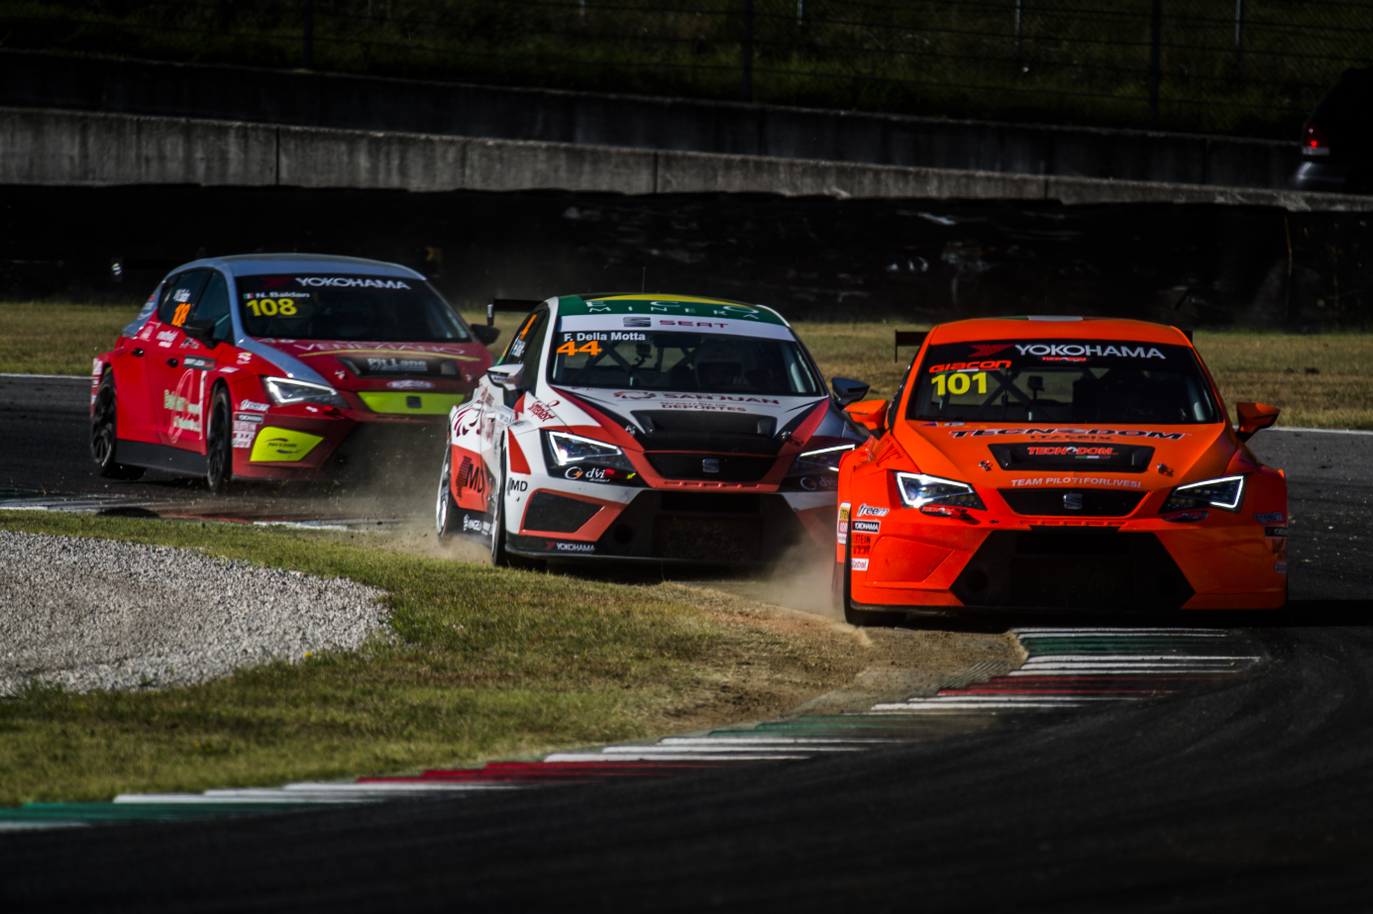

*SEAT LEON Eurocup in Mugello, Italy*

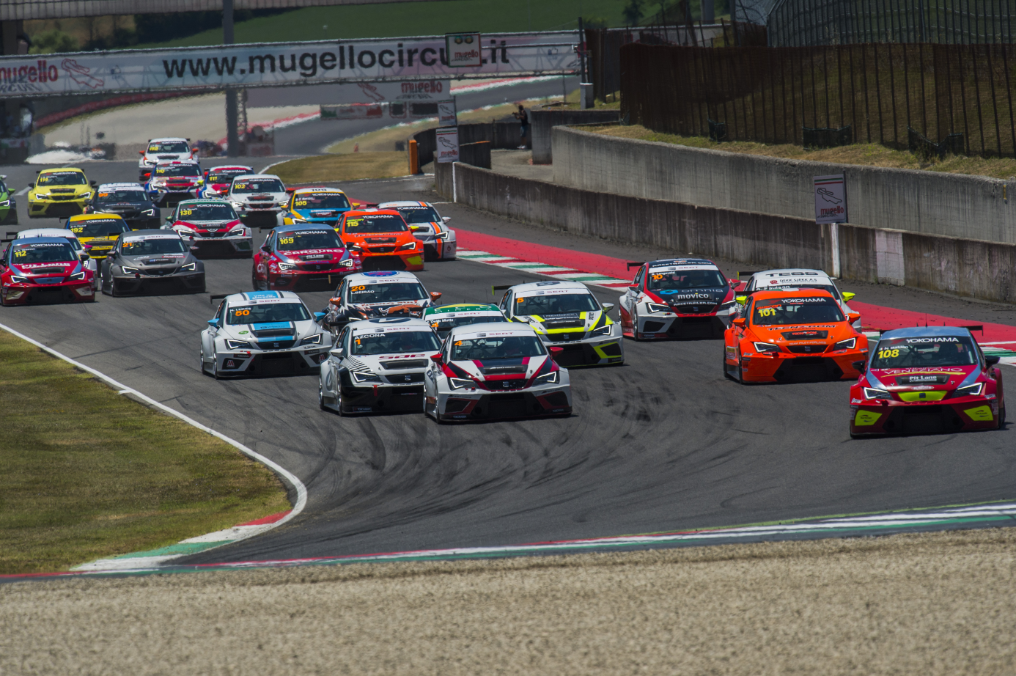

*YOKOHAMA is the Exclusive Tyre supplier to the SEAT LEON Eurocup*

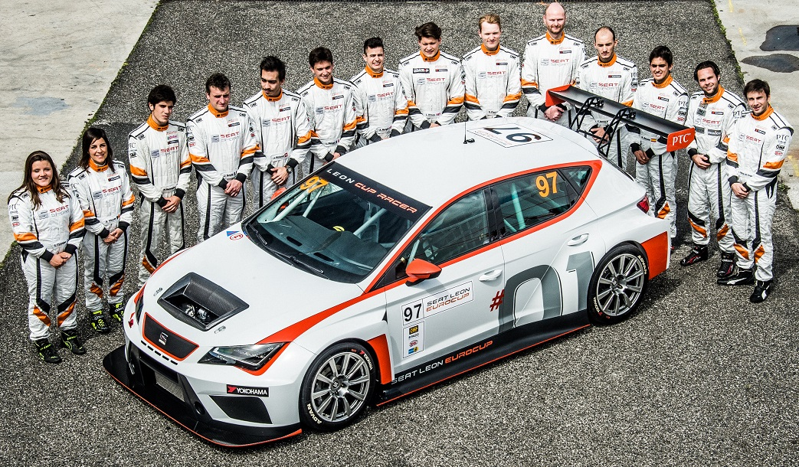

*Drivers of the 2016 SEAT LEON Eurocup*